WP Lab 10 - Databases – Part I

Q1 - 1. Design a web site using Django, which is a website directory – A site containing
links to other websites. A web page has different categories.
• A category table has a name, number of visits, and number of likes.
• A page table refers to a category, has a title, URL, and many views.
Design a form that populates the above database and displays it.

Code -

#forms.py -
from django import forms
from .models import Category, Page

class CategoryForm(forms.ModelForm):
class Meta:
model = Category
fields = ['name', 'number_of_visits', 'number_of_likes']

class PageForm(forms.ModelForm):
class Meta:
model = Page
fields = ['category', 'title', 'url', 'views']

#models.py -
from django.db import models

class Category(models.Model):
name = models.CharField(max_length=255)
number_of_visits = models.IntegerField(default=0)
number_of_likes = models.IntegerField(default=0)

def __str__(self):
return self.name

class Page(models.Model):
category = models.ForeignKey(Category, on_delete=models.CASCADE, related_name='pages')
title = models.CharField(max_length=255)
url = models.URLField()
views = models.IntegerField(default=0)

def __str__(self):
return self.title

#views.py -
from django.shortcuts import render, redirect
from .models import Category, Page
from .forms import CategoryForm, PageForm

def home(request):
categories = Category.objects.all()
return render(request, 'directory/home.html', {'categories': categories})

def add_category(request):
if request.method == 'POST':
form = CategoryForm(request.POST)
if form.is_valid():
form.save()
return redirect('home')
else:
form = CategoryForm()
return render(request, 'directory/add_category.html', {'form': form})

def add_page(request):
if request.method == 'POST':
form = PageForm(request.POST)
if form.is_valid():
form.save()
return redirect('home')
else:
form = PageForm()
return render(request, 'directory/add_page.html', {'form': form})

#urls.py -
from django.urls import path
from . import views

urlpatterns = [
path('', views.home, name='home'),
path('add_category/', views.add_category, name='add_category'),
path('add_page/', views.add_page, name='add_page'),
]

#home.html -
<!DOCTYPE html>
<html lang="en">
<head>
<meta charset="UTF-8">
<meta name="viewport" content="width=device-width, initial-scale=1.0">
<title>Website Directory</title>
<link href="https://cdn.jsdelivr.net/npm/bootstrap@5.3.0-alpha1/dist/css/bootstrap.min.css" rel="stylesheet" integrity="sha384-KyZXEJx5XQxCk3M2Ry27U1rFjZUt7eK5zj5czHV5uZJ3xnFuLOp0UfwP2lZYYs9X" crossorigin="anonymous">
<style>
body {
background-color: #f8f9fa;
padding-top: 50px;
}
.card {
border-radius: 10px;
box-shadow: 0 4px 10px rgba(0, 0, 0, 0.1);
margin-bottom: 30px;
}
.card-header {
background-color: #007bff;
color: white;
text-align: center;
padding: 15px;
font-size: 1.25rem;
}
.card-body {
padding: 20px;
background-color: #ffffff;
border-radius: 10px;
}
.category-card {
margin-bottom: 40px;
}
.header-title {
font-size: 2.5rem;
font-weight: 700;
margin-bottom: 40px;
}
.back-btn {
margin-top: 30px;
}
.btn-primary, .btn-success {
border-radius: 10px;
}
</style>
</head>
<body>

<div class="container">
<h1 class="text-center header-title">Website Directory</h1>

<div class="row">
{% for category in categories %}
<div class="col-md-4">
<div class="card">
<div class="card-header">
{{ category.name }}
</div>
<div class="card-body">
<p><strong>Visits:</strong> {{ category.number_of_visits }} | <strong>Likes:</strong> {{ category.number_of_likes }}</p>
<h5>Pages:</h5>
<ul class="list-unstyled">
{% for page in category.pages.all %}
<li>
<a href="{{ page.url }}" class="btn-link">{{ page.title }}</a> - <span class="badge bg-secondary">{{ page.views }} Views</span>
</li>
{% endfor %}
</ul>
</div>
<div class="card-footer text-center">
<a href="{% url 'add_page' %}" class="btn btn-primary">Add Page</a>
</div>
</div>
</div>
{% endfor %}
</div>

<div class="text-center back-btn">
<a href="{% url 'add_category' %}" class="btn btn-success btn-lg">Add New Category</a>
</div>
</div>

<script src="https://cdn.jsdelivr.net/npm/bootstrap@5.3.0-alpha1/dist/js/bootstrap.bundle.min.js" integrity="sha384-kaBdVe+Ioe1bnMXVknxR7/5zBe3Cmv7Wq4xBxzJbh3aRzUvhfUeCpq9hzlyTHYj8" crossorigin="anonymous"></script>
</body>
</html>

#add_category.html -
<!DOCTYPE html>
<html lang="en">
<head>
<meta charset="UTF-8">
<meta name="viewport" content="width=device-width, initial-scale=1.0">
<title>Add Category</title>
<link href="https://cdn.jsdelivr.net/npm/bootstrap@5.3.0-alpha1/dist/css/bootstrap.min.css" rel="stylesheet" integrity="sha384-KyZXEJx5XQxCk3M2Ry27U1rFjZUt7eK5zj5czHV5uZJ3xnFuLOp0UfwP2lZYYs9X" crossorigin="anonymous">
<style>
body {
background-color: #f8f9fa;
padding-top: 50px;
}
.form-container {
max-width: 600px;
margin: 0 auto;
background-color: white;
padding: 40px;
border-radius: 15px;
box-shadow: 0 4px 10px rgba(0, 0, 0, 0.1);
}
.form-title {
font-size: 2rem;
font-weight: 700;
text-align: center;
margin-bottom: 30px;
}
.form-group {
margin-bottom: 20px;
}
.btn {
width: 100%;
border-radius: 10px;
}
.back-btn {
text-align: center;
margin-top: 20px;
}
</style>
</head>
<body>

<div class="container">
<div class="form-container">
<h1 class="form-title">Add New Category</h1>
<form method="post" id="category-form">
{% csrf_token %}
<div class="form-group">
<label for="id_name" class="form-label">Category Name</label>
{{ form.name }}
</div>
<div class="form-group">
<label for="id_number_of_visits" class="form-label">Number of Visits</label>
{{ form.number_of_visits }}
</div>
<div class="form-group">
<label for="id_number_of_likes" class="form-label">Number of Likes</label>
{{ form.number_of_likes }}
</div>
<button type="submit" class="btn btn-success">Save Category</button>
</form>
<div class="back-btn">
<a href="{% url 'home' %}" class="btn btn-outline-secondary">Back to Home</a>
</div>
</div>
</div>

<script src="https://cdn.jsdelivr.net/npm/bootstrap@5.3.0-alpha1/dist/js/bootstrap.bundle.min.js" integrity="sha384-kaBdVe+Ioe1bnMXVknxR7/5zBe3Cmv7Wq4xBxzJbh3aRzUvhfUeCpq9hzlyTHYj8" crossorigin="anonymous"></script>
</body>
</html>

#add_page.html -
<!DOCTYPE html>
<html lang="en">
<head>
<meta charset="UTF-8">
<meta name="viewport" content="width=device-width, initial-scale=1.0">
<title>Add Page</title>
<link href="https://cdn.jsdelivr.net/npm/bootstrap@5.3.0-alpha1/dist/css/bootstrap.min.css" rel="stylesheet" integrity="sha384-KyZXEJx5XQxCk3M2Ry27U1rFjZUt7eK5zj5czHV5uZJ3xnFuLOp0UfwP2lZYYs9X" crossorigin="anonymous">
<style>
body {
background-color: #f8f9fa;
padding-top: 50px;
}
.form-container {
max-width: 600px;
margin: 0 auto;
background-color: white;
padding: 40px;
border-radius: 15px;
box-shadow: 0 4px 10px rgba(0, 0, 0, 0.1);
}
.form-title {
font-size: 2rem;
font-weight: 700;
text-align: center;
margin-bottom: 30px;
}
.form-group {
margin-bottom: 20px;
}
.btn {
width: 100%;
border-radius: 10px;
}
.back-btn {
text-align: center;
margin-top: 20px;
}
</style>
</head>
<body>

<div class="container">
<div class="form-container">
<h1 class="form-title">Add New Page</h1>
<form method="post" id="page-form">
{% csrf_token %}
<div class="form-group">
<label for="id_title" class="form-label">Page Title</label>
{{ form.title }}
</div>
<div class="form-group">
<label for="id_url" class="form-label">Page URL</label>
{{ form.url }}
</div>
<div class="form-group">
<label for="id_category" class="form-label">Category</label>
{{ form.category }}
</div>
<button type="submit" class="btn btn-success">Save Page</button>
</form>
<div class="back-btn">
<a href="{% url 'home' %}" class="btn btn-outline-secondary">Back to Home</a>
</div>
</div>
</div>

<script src="https://cdn.jsdelivr.net/npm/bootstrap@5.3.0-alpha1/dist/js/bootstrap.bundle.min.js" integrity="sha384-kaBdVe+Ioe1bnMXVknxR7/5zBe3Cmv7Wq4xBxzJbh3aRzUvhfUeCpq9hzlyTHYj8" crossorigin="anonymous"></script>
</body>
</html>

Output -
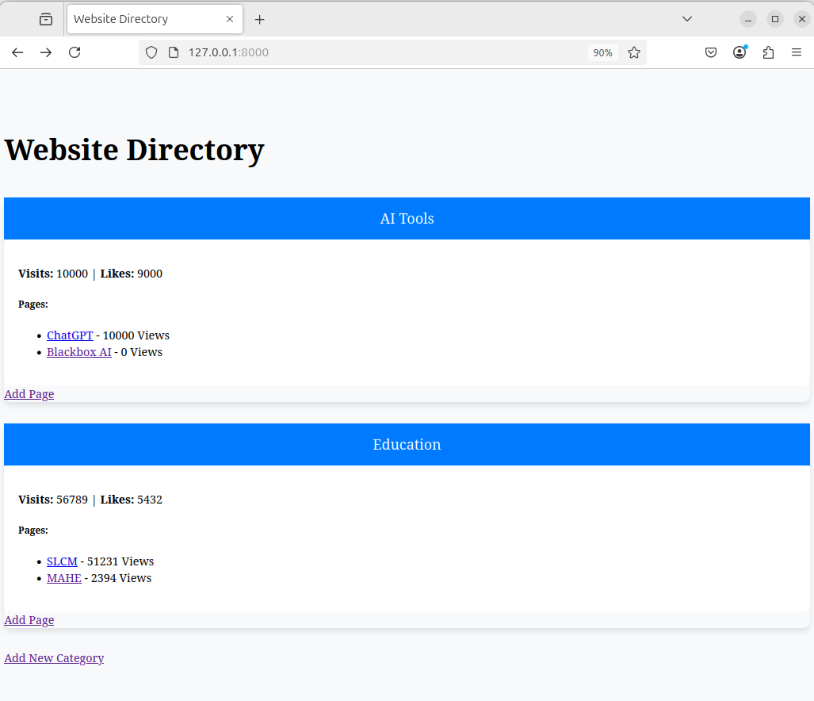
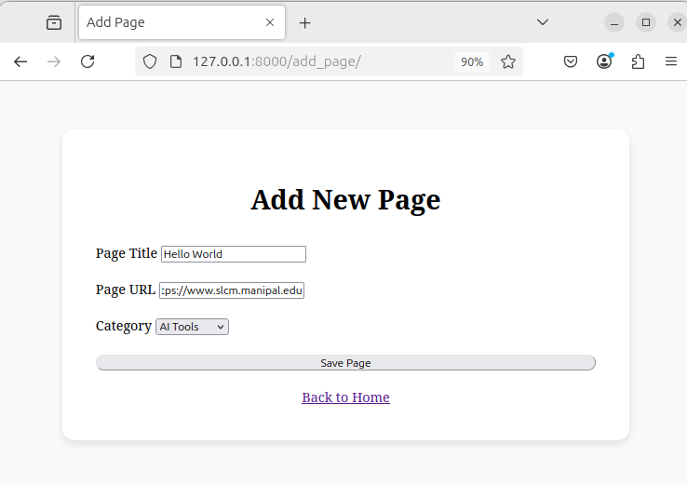
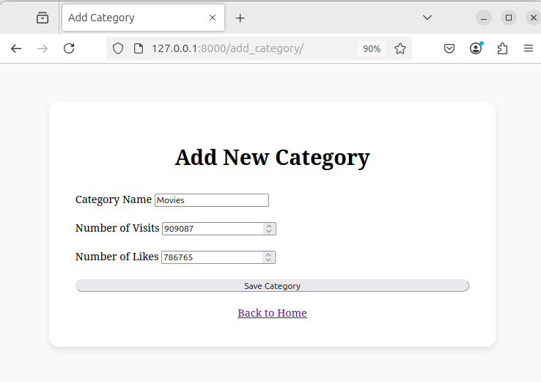
Q2 - Consider the following tables:
WORKS(person-name,Company-name,Salary)
LIVES(Person_name, Street, City)
Assume Table data suitably. Design a Django webpage and include an option to
insert data into WORKS table by accepting data from the user using TextBoxes.
Also, include an option to retrieve the names of people who work for a
particular company along with the cities they live in (particular company name
must be accepted from the user).

Code -

#urls.py -
from django.urls import path
from . import views

urlpatterns = [
path('insert/', views.insert_data, name='insert_data'),
path('retrieve/', views.retrieve_data, name='retrieve_data'),
]

#models.py -
from django.db import models

class Works(models.Model):
person_name = models.CharField(max_length=100)
company_name = models.CharField(max_length=100)
salary = models.DecimalField(max_digits=10, decimal_places=2)

def __str__(self):
return self.person_name

class Lives(models.Model):
person_name = models.ForeignKey(Works, on_delete=models.CASCADE)
street = models.CharField(max_length=100)
city = models.CharField(max_length=100)

def __str__(self):
return f"{self.person_name.person_name} lives in {self.city}"

#forms.py -
from django import forms
from .models import Works, Lives

class WorksForm(forms.ModelForm):
class Meta:
model = Works
fields = ['person_name', 'company_name', 'salary']

class LivesForm(forms.ModelForm):
class Meta:
model = Lives
fields = ['person_name', 'street', 'city']

# Override the __init__ method to set the queryset for person_name
def __init__(self, *args, **kwargs):
super(LivesForm, self).__init__(*args, **kwargs)
self.fields['person_name'].queryset = Works.objects.all()

#insert_data.html-
<!DOCTYPE html>
<html lang="en">
<head>
<meta charset="UTF-8" />
<meta name="viewport" content="width=device-width, initial-scale=1.0" />
<title>Insert Data</title>
<style>
body {
font-family: "Arial", sans-serif;
background-color: #f4f7fc;
margin: 0;
padding: 0;
}
header {
background-color: #4caf50;
color: white;
text-align: center;
padding: 20px;
}
.container {
width: 50%;
margin: 30px auto;
background-color: white;
border-radius: 8px;
box-shadow: 0 4px 10px rgba(0, 0, 0, 0.1);
padding: 30px;
}
h2 {
font-size: 1.5em;
margin-bottom: 15px;
color: #333;
}
form {
display: flex;
flex-direction: column;
}
label {
margin-bottom: 5px;
color: #555;
font-weight: bold;
}
input[type="text"],
input[type="number"] {
padding: 10px;
margin-bottom: 20px;
border: 1px solid #ccc;
border-radius: 5px;
font-size: 1em;
}
button {
padding: 12px 20px;
background-color: #4caf50;
color: white;
border: none;
border-radius: 5px;
font-size: 1.1em;
cursor: pointer;
transition: background-color 0.3s ease;
}
button:hover {
background-color: #45a049;
}
.form-section {
margin-bottom: 25px;
}
</style>
</head>
<body>
<header>
<h1>Insert Data</h1>
</header>
<div class="container">
<form method="post">
{% csrf_token %}
<div class="form-section">
<h2>Work Information</h2>
{{ works_form.as_p }}
</div>

<div class="form-section">
<h2>Living Information</h2>
{{ lives_form.as_p }}
</div>

<button type="submit">Submit</button>
</form>

<a href="retrieve_data.html">retrieve data</a>
</div>
</body>
</html>

#retreive_data.html -
<!DOCTYPE html>
<html lang="en">
<head>
<meta charset="UTF-8" />
<meta name="viewport" content="width=device-width, initial-scale=1.0" />
<title>Retrieve Data</title>
<style>
body {
font-family: "Arial", sans-serif;
background-color: #f4f7fc;
margin: 0;
padding: 0;
}
header {
background-color: #4caf50;
color: white;
text-align: center;
padding: 20px;
}
.container {
width: 50%;
margin: 30px auto;
background-color: white;
border-radius: 8px;
box-shadow: 0 4px 10px rgba(0, 0, 0, 0.1);
padding: 30px;
}
h1 {
color: #333;
}
form {
margin-bottom: 30px;
}
label {
font-size: 1.1em;
margin-bottom: 10px;
color: #555;
}
input[type="text"] {
padding: 10px;
margin-bottom: 20px;
width: 100%;
border: 1px solid #ccc;
border-radius: 5px;
font-size: 1em;
}
button {
padding: 12px 20px;
background-color: #4caf50;
color: white;
border: none;
border-radius: 5px;
font-size: 1.1em;
cursor: pointer;
transition: background-color 0.3s ease;
}
button:hover {
background-color: #45a049;
}
.results {
margin-top: 20px;
}
ul {
padding: 0;
list-style: none;
}
li {
padding: 8px;
background-color: #f9f9f9;
margin-bottom: 10px;
border-radius: 5px;
font-size: 1.1em;
color: #555;
}
.no-results {
font-size: 1.2em;
color: #ff5722;
font-weight: bold;
}
</style>
</head>
<body>
<header>
<h1>Retrieve Data</h1>
</header>
<div class="container">
<form method="post">
{% csrf_token %}
<label for="company_name">Enter Company Name:</label>
<input type="text" name="company_name" id="company_name" />
<button type="submit">Search</button>
</form>

<div class="results">
<h2>Results:</h2>
<ul>
{% for work in results %}
<li>
{{ work.person_name }} - {{ work.company_name }} - {{ work.salary }}
</li>
{% empty %}
<li class="no-results">No results found.</li>
{% endfor %}
</ul>
</div>
</div>
</body>
</html>

Output -

